## Creating Offline Solutions with SharePoint Workspace

**Lab Time**: 60 minutes

**Lab Folder**: C:\Student\Labs\Workspace

**Lab Overview:** In this lab you will work with SharePoint Workspace 2010 and discover how it provides a great solution to take your SharePoint data offline. You will also discover how you can surface you line of business application data directly through SharePoint Workspace 2010 and make changes to it as necessary. Also, you will make use of InfoPath 2010 to edit SharePoint list forms which will then be available through the SharePoint Workspace 2010.

### Exercise 1: Synchronize using SharePoint Workspace 2010

In this exercise, you will synchronize your site to a SharePoint Workspace 2010.

**Note:** This exercise will make use of Business Connectivity Services (BCS) and external content types (ECTs) exposing information in a SQL Server database to SharePoint. The BCS lab in this course walked you through creating a new site collection, external content type and external list. **To do this lab you need to first do exercise 1 in the BCS lab first.**

1. Using the browser navigate to the site **http://intranet.wingtip.com/sites/bcs**.
2. Using the ribbon select **Site Actions » Sync to SharePoint Workspace**. The **Account Configuration Wizard** for SharePoint Workspace should start up.
   1. Click the radio button for **Create a new account** and click the **Next** button.
   2. On the next screen, provide the following information:

**Name:** Student

**Email Address:** student@wingtip.com

* 1. Click the **Finish** button.

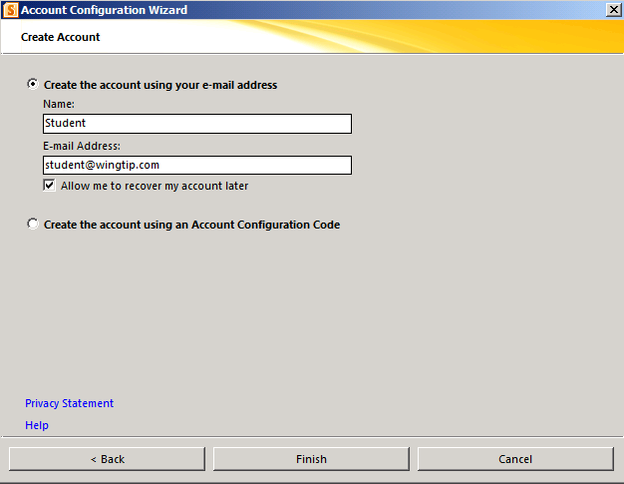

1. A dialog box will prompt you to confirm that you want to sync the BCS site to your computer. Click the **OK** button. The synchronization should start syncing your BCS site to your computer.

**Note:** This process may take several minutes so please be patient.

1. A dialog box may pop up saying that the publisher cannot be verified. Click the **Install** button. Once the **Microsoft Office Customization Installer** finishes installing, click the **Close** button.
2. When the SharePoint Workspace 2010 is done synchronizing the BCS site to your computer it will display the completion status. Note that the Calendar list and Site Pages library are not compatible with SharePoint Workspace. These lists can only be viewable through the browser and their data cannot be managed in SharePoint Workspace.

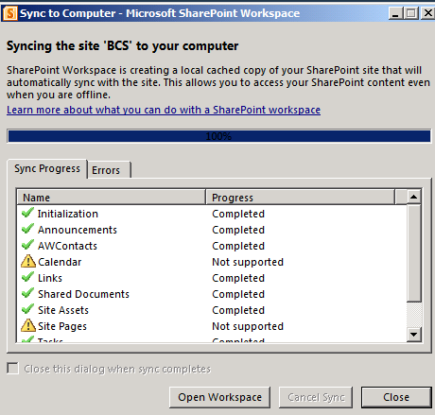

1. Click the **Open Workspace** button. Note the Quick Launch of SharePoint Workspace shows the list categories Document, Lists, External Lists, Discussions and Available on Server. The Available on Server category shows all the Lists and Libraries that are not synchronized in SharePoint Workspace and are only available on the server through the browser.
2. You will now test out the synchronization functionality:
3. Click the **Announcements** list.

The default Get Started with Microsoft SharePoint Foundation announcement should already be there. It should also show you the preview pane showing you the information of the announcement below.

1. To create a new announcement, use the ribbon: **New » Announcement**. A new form will open to create your new announcement:

**Title:** Office closing early to observe Memorial Day

**Body:** Our office will be closing at 2pm on Memorial Day. Please take note.

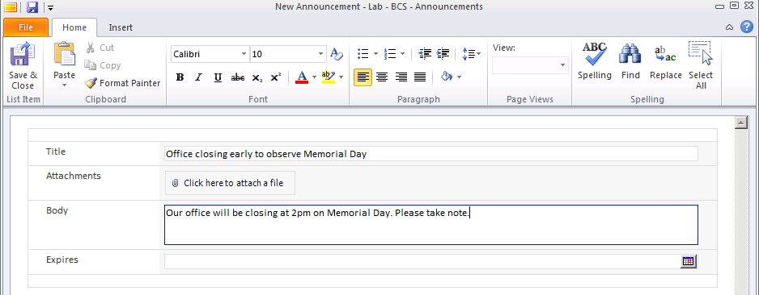

* 1. Click the **Save & Close** button in the ribbon to save this announcement.

1. The new announcement will appear in the list with the details in the lower pane.

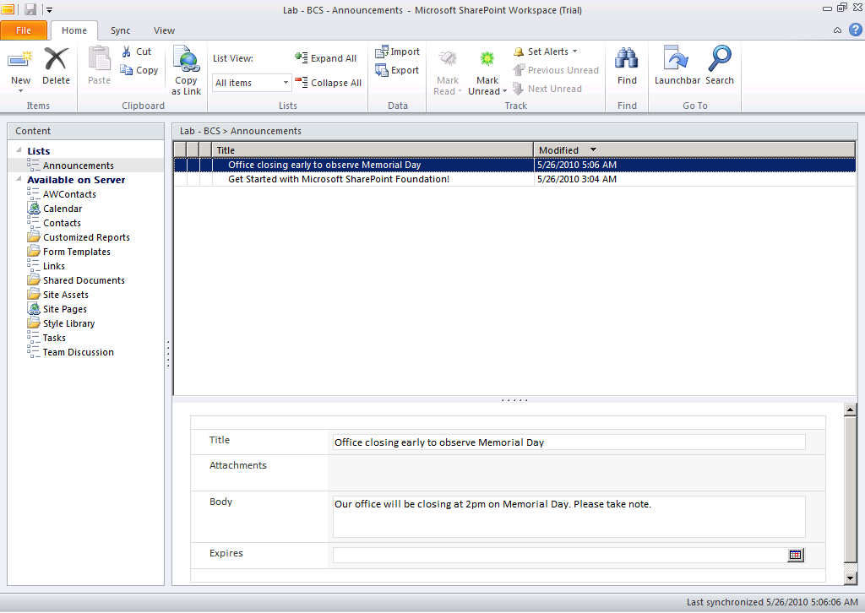

1. Browse to the **http://intranet.wingtip.com/sites/bcs** site in the browser and use the ribbon to do the following: **Site Actions » All Site Content » Announcements**. You should see that the new announcement in the list.
2. Click the **Tasks** list in the Quick Launch and create a new item.
3. Return to **SharePoint Workspace 2010** and click the **Tasks** list in the **Content** pane. Give SharePoint Workspace 2010 a moment to sync. Eventually you’ll see the new item appear in the list.

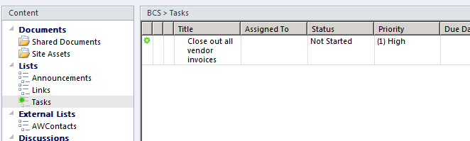

1. Select the task in **SharePoint Designer 2010**. The green icon will disappear because this item has been read. The preview pane will show the information below about this task.
2. You will now work with Documents in SharePoint Workspace 2010.
3. Click **Shared Documents** in the Quick Launch
4. In the ribbon select **Add Documents**.
5. In the **Add Files** dialog select the file [[LAB FILES]]\StarterFiles\Hardware specs.docx in that folder.
6. The Hardware specs.docx document will appear in SharePoint Workspace 2010 under in the **Shared Documents** library.
7. In the browser navigate to the **http://intranet.wingtip.com/sites/bcs** site.
8. Go to the **Shared Documents** library. You should see the Hardware specs.docx document.
9. Click the document to open it up. When the **Open Document** dialog box appears, click the radio button for **Edit** and click **OK**. The Hardware specs.docx document will load in **Word 2010**.
10. Add the following text to the top of the document: **Change made through opening document from browser.**
11. **Save** and **Close** the document in Word 2010.
12. Go back to **SharePoint Workspace 2010** and double click the Hardware specs.docx document to open it up from SharePoint Workspace 2010. The change that you had made through the browser should be in the Word document.

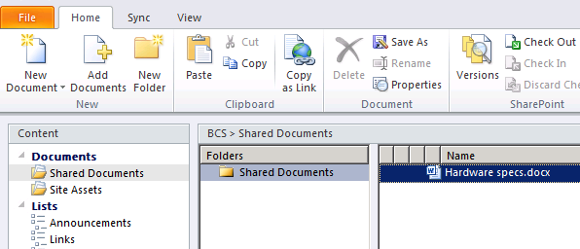

1. Add additional text to the top of the document: **Change made through opening document from SharePoint Workspace**.
2. **Save** and **Close** the document in Word 2010.
3. Go back to the browser and open the document. You should see the changes you made in SharePoint Workspace 2010.
4. Close the Hardware specs document.

Since you are working online with the SharePoint environment, the changes are propagating very quickly. You will now explore what happens when you are working offline in a document and you try to save your changes when you are online.

1. In **SharePoint Workspace 2010** select the **File** tab. From the backstage page click the **Connection Settings** button and select the **Work Offline** option to simulate working disconnected.

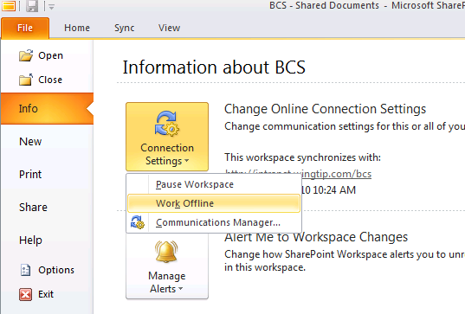

1. Click the **File** tab.
2. Double click the Hardware specs.docx document to open it up. A pop up should appear telling you that you are working on the Offline Copy of the document.
3. Add some additional text to the document: **Change made through Workspace while working offline**.
4. **Save** the document in Word 2010. Notice below there should be an **Upload Pending message.**
5. **Close** the document.

This document has not been sync’d with SharePoint. Once you are back online SharePoint Workspace 2010 will automatically synchronize with the server.

1. Click the **File** tab, **Connection Settings** and select **Work Offline** option to toggle your connected status.
2. Click the **File** tab once again to return to SharePoint Workspace 2010. In the status bar at the bottom of the application a message will indicate it is synchronizing with the server.
3. Go to the **Shared Documents** library in the browser and click the Hardware specs.docx document. You will notice the changes made while offline through SharePoint Workspace 2010. Go ahead and close the document now and return to SharePoint Workspace 2010.
4. To check out the sync status of your SharePoint site, use the ribbon to select **Sync » Sync Status**.
5. The **Sync Status** window shows the synchronization status of your SharePoint Workspace 2010 with the SharePoint site.

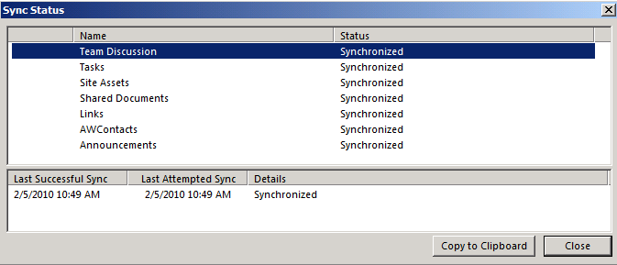

1. Click the **Close** button to close the **Sync Status** window and return to SharePoint Workspace 2010.
2. If you want to stop synchronizing a List or Library from SharePoint Workspace 2010 to SharePoint do the following:
3. Click the **Announcements** list
4. In the ribbon select **Sync » Change Sync Settings » Disconnect “Announcements” from Server** option.

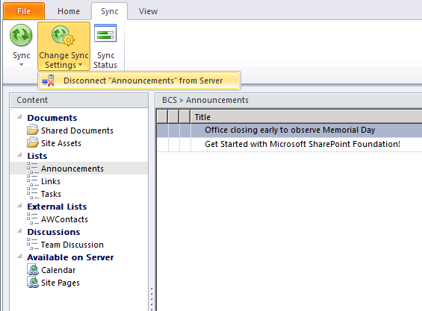

* 1. A dialog box will appear warning you that this will disconnect Announcements list from the server. Click the **Yes** button.
  2. The **Announcements** list will appear in the **Available on Server** category in the Quick Launch.

1. Click the **Announcements** list. SharePoint Workspace 2010 will state the list is not currently synchronized with the server but can be reconnected to it by clicking **Connect “Announcements” to Server** link. Using this process, reconnect the **Announcements** list in SharePoint Workspace 2010 to SharePoint.

In this exercise you worked with content while online and offline using SharePoint Workspace 2010.

### Exercise 2: Working with External Lists in SharePoint Workspace

In this exercise, you will work with an external list through SharePoint Workspace.

1. Open the **http://intranet.wingtip.com/sites/bcs** site in **SharePoint Workspace 2010**.
2. There is an **External List** called **AWContacts**. This represents the External List that is getting the information from the Contacts table in the Adventure Works database.
3. Select the **AWContacts** list. All the contacts in that list will appear. When a contact is selected its details are shown in the Preview Pane at the bottom.

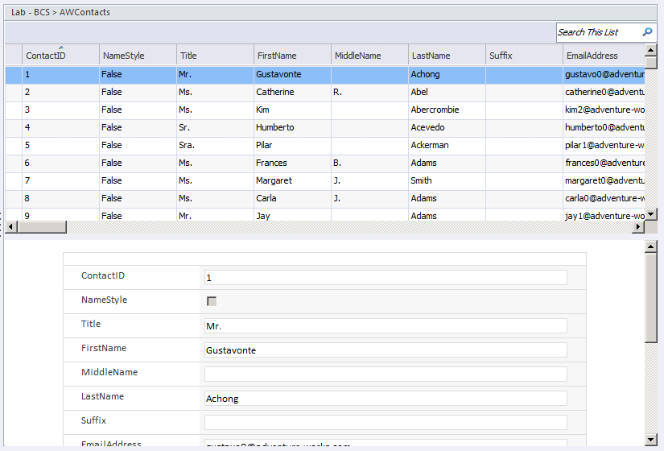

1. **Double click** the first contact.
2. SharePoint Workspace 2010 will open a form showing you the first contact’s information.
3. Change the **phone number** of that contact to **413-929-3837**.
4. Click the **Save & Close** button in the ribbon.

This update has been saved in the **Contacts** table in the **Adventure Works** database.

1. Go to the **http://intranet.wingtip.com/site/bcs** site in the browser and select **All Site Content** in the Quick Launch.
2. Select the **AWContacts** list. Verify that the phone number for the first contact has changed.

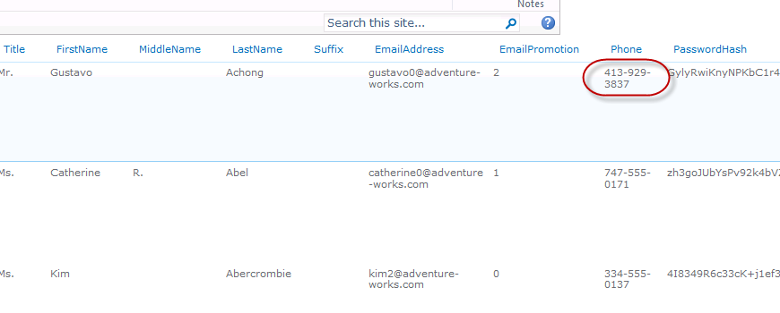

1. Check the data in the **Adventure Works** database:
2. **Start » All Programs » Microsoft SQL Server 2008 R2 » SQL Server Management Studio**
   1. In the **Connect to Server** dialog box use the following:

**Server name:** WINGTIPSERVER

**Windows Authentication**

1. In the **Object Explorer** task pane, click the **[+]** sign to expand the **Database** node, then expand the **AdventureWorks** node, then expand the **Tables** node.
2. Right-click the **dbo.Contact** and select **Select » Select Top 1000 Rows** option.
3. Verify the first contact’s phone number has changed.

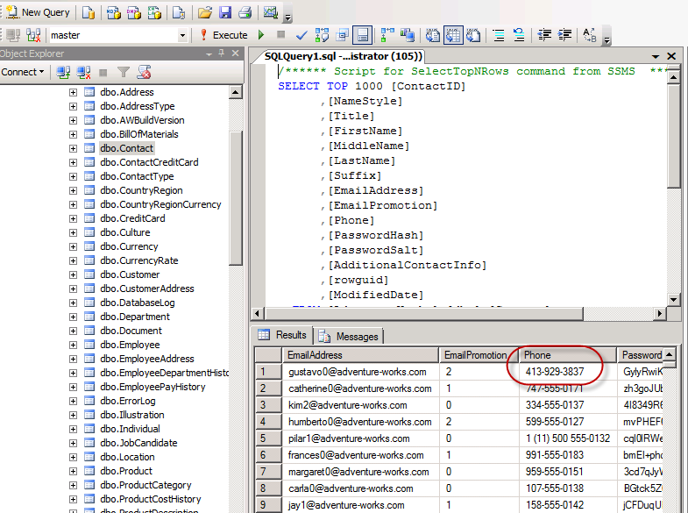

In this exercise you interacted and managed data that lives in a SQL Server database and is exposed using SharePoint’s BCS External List capability.

### Exercise 3: Use InfoPath to Edit a SharePoint List Form

In this exercise, you will use InfoPath to edit the form of a SharePoint list.

1. Open the **http://intranet.wingtip.com/sites/bcs** site in **SharePoint Workspace 2010**.
2. Click the **Tasks** list. Observe the form that is currently presented for the Task list in the Preview Pane. You will be changing this form using InfoPath 2010.
3. Using the browser, navigate to the **http://intranet.wingtip.com/sites/bcs** site.
4. Select the **Tasks** list in the Quick Launch.
5. In the ribbon select **List » Customize Form**. The Task list new/edit form will open in InfoPath 2010.
6. Using the ribbon select **Page Design » {Select the theme called the SharePoint – Azure}**.

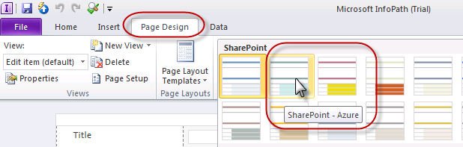

1. Click and drag the **Title** text box from its current location to the first row in this table.
2. With the **Title** text box selected, in the ribbon click **Home » Bold** button and change the **Font Size** using the drop down to **18**.
3. Put the cursor immediately to the left of the **Title** text box and type in the word **Title**.
4. Select the word **Title**, make it **bold** and change the **Font Size** to **18**.

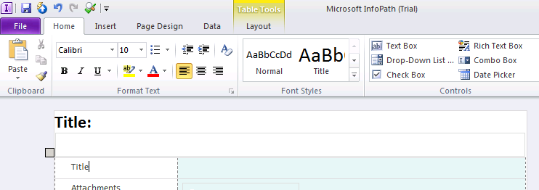

1. Now put the cursor in the second row of this table where the original Title label is located and delete that row using the ribbon: **Layout » Delete » Rows**.
2. Highlight all the labels in the first column from **Attachment** to **Due Date**. Using the ribbon make them all **bold** and **blue**:

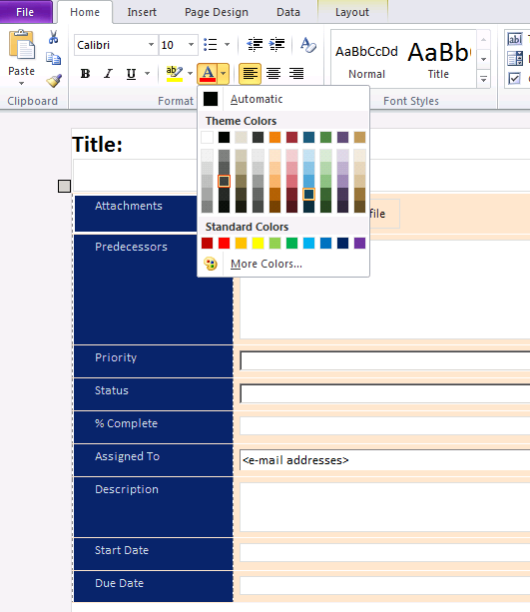

You are now ready to post this form back to its original location in the task list.

1. In the ribbon select **File » Quick Publish**.
2. Close **InfoPath 2010**.
3. Test the changes and verify how this form looks by going to the **Tasks** list in the browser and clicking the **Add new item** link.
4. The new form should now appear. Type some text in the **Title** text box and that text should appear to be **bold** and with **Font Size** of **18**.

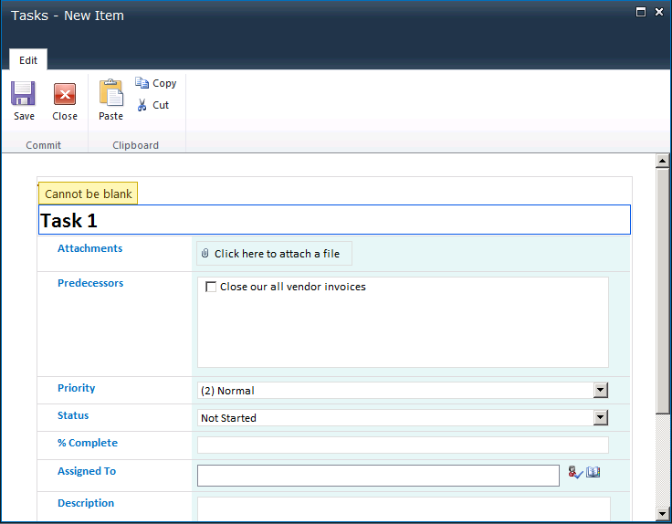

1. Close dialog box without saving the information.
2. Go to back to **SharePoint Workspace 2010**.
3. In the ribbon select the **Sync » Sync** button to synchronize SharePoint Workspace 2010.
4. Double click an item in the list to view the new form in the Preview Pane:

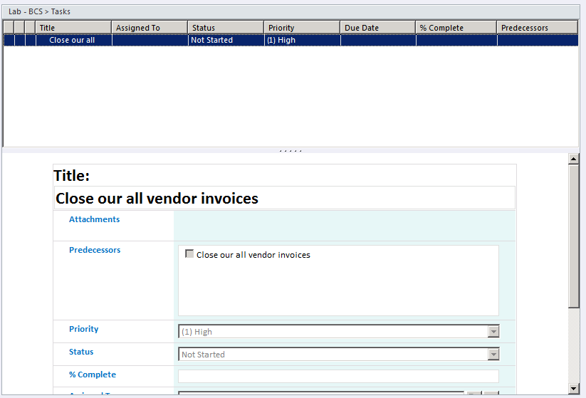

In this exercise you modified one of the out-of-the-box forms with InfoPath 2010 and observed how it was synchronized between the Web interface and SharePoint Workspace 2010.

### Exercise 4: Security in SharePoint Workspace

In this exercise, you will see how security is handled in SharePoint Workspace.

1. In the browser navigate to the **http://intranet.wingtip.com/sites/bcs** site.
2. Using the ribbon select **Site Actions » Site Settings**
3. Select **Site Administration »** **Search and offline availability**.

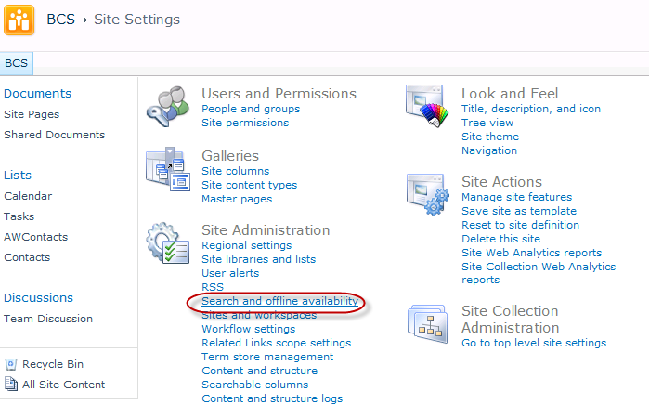

1. From the Search and offline availability page, look for the **Offline Client Availability** section. This is where you can clients, such as SharePoint Workspace 2010 from downloading the site.
2. Select the **No** radio button and then click **OK** button.

Verify this change by logging in as another user.

1. Login as another user on the virtual machine:
2. **Start » All Programs » Accessories » Remote Desktop Connection**
3. When prompted for the server, enter **WINGTIPSERVER**
4. Login as **Janice**.
5. In the browser navigate to the **http://intranet.wingtip.com/sites/bcs** site.
6. Using the ribbon select **Site Actions**. Note that the **Sync to SharePoint Workspace** option is not available in the menu:

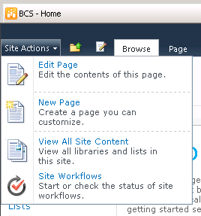

1. Minimize this Remote Desktop session.
2. Repeat the process you did to disable the offline clients except re-enable it this time.
3. Go back to the Remote Desktop session for Janice. Refresh the site in the browser.
4. The **Site Actions** menu will snow show the **Sync to SharePoint Workspace** option:

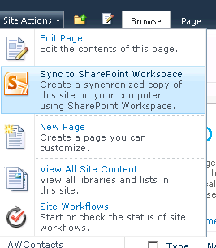

In this exercise you modified the offline settings for a SharePoint site to allow and disallow it to be synchronized offline.